Priority scheduling Pre-emptive
Code: #include<stdio.h>
int main(){
int n;
printf("Enter number of processes: ");
scanf("%d",&n);
int pid[n],at[n],bt[n],pr[n],ct[n],tat[n],wt[n],completed[n];
for(int i=0;i<n;i++){
pid[i]=i+1;
printf("Enter AT BT Priority for P%d: ",pid[i]);
scanf("%d%d%d",&at[i],&bt[i],&pr[i]);
completed[i]=0;
}
int current_time=0,completed_count=0;
while(completed_count<n){
int highest_priority=9999,selected=-1;
for(int i=0;i<n;i++){
if(at[i]<=current_time && completed[i]==0){
if(pr[i]<highest_priority){
highest_priority=pr[i];
selected=i;
}}}
if(selected==-1){
current_time++;
}else{
ct[selected]=current_time+bt[selected];
tat[selected]=ct[selected]-at[selected];
wt[selected]=tat[selected]-bt[selected];
current_time=ct[selected];
completed[selected]=1;
completed_count++;
}}
printf("PID\tAT\tBT\tPR\tCT\tTAT\tWT\n");
for(int i=0;i<n;i++){
printf("P%d\t%d\t%d\t%d\t%d\t%d\t%d\n",pid[i],at[i],bt[i],pr[i],ct[i],tat[i],wt[i]);
}
printf("\nOjashwi Shrestha 1WA24CS197\n");
return 0;
}
Output:
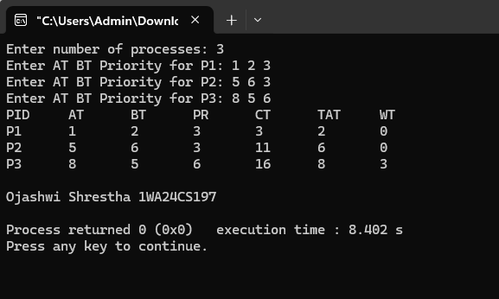

Priority Scheduling Pre-emptive
Code: #include<stdio.h>
int main(){
int n;
printf("Enter number of processes: ");
scanf("%d",&n);
int pid[n],at[n],bt[n],pr[n],rt[n],ct[n],tat[n],wt[n];
for(int i=0;i<n;i++){
pid[i]=i+1;
printf("Enter AT BT Priority for P%d: ",pid[i]);
scanf("%d%d%d",&at[i],&bt[i],&pr[i]);
rt[i]=bt[i];
}
int completed=0,current_time=0;
while(completed<n){
int highest_priority=9999,selected=-1;
for(int i=0;i<n;i++){
if(at[i]<=current_time && rt[i]>0){
if(pr[i]<highest_priority){
highest_priority=pr[i];
selected=i;
}}}
if(selected==-1){
current_time++;
}else{
rt[selected]--;
current_time++;
if(rt[selected]==0){
ct[selected]=current_time;
tat[selected]=ct[selected]-at[selected];
wt[selected]=tat[selected]-bt[selected];
completed++;
}}}
printf("PID\tAT\tBT\tPR\tCT\tTAT\tWT\n");
for(int i=0;i<n;i++){
printf("P%d\t%d\t%d\t%d\t%d\t%d\t%d\n",pid[i],at[i],bt[i],pr[i],ct[i],tat[i],wt[i]);
}
printf("\nOjashwi Shrestha 1WA24CS197\n");
return 0;
}
Output: 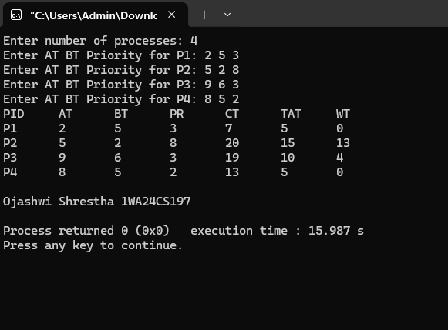

Round Robin
Code: #include<stdio.h>
int main(){
int n,tq;
printf("Enter number of processes: ");
scanf("%d",&n);
printf("Enter Time Quantum: ");
scanf("%d",&tq);
int pid[n],at[n],bt[n],rt[n],ct[n],tat[n],wt[n];
printf("Enter AT and BT\n");
for(int i=0;i<n;i++){
pid[i]=i+1;
scanf("%d%d",&at[i],&bt[i]);
rt[i]=bt[i];
}
int completed=0,current_time=0;
while(completed<n){
int executed=0;
for(int i=0;i<n;i++){
if(at[i]<=current_time && rt[i]>0){
executed=1;
if(rt[i]>tq){
current_time+=tq;
rt[i]-=tq;
}else{
current_time+=rt[i];
ct[i]=current_time;
tat[i]=ct[i]-at[i];
wt[i]=tat[i]-bt[i];
rt[i]=0;
completed++;
}}}
if(executed==0){
current_time++;
}}
printf("PID\tAT\tBT\tCT\tTAT\tWT\n");
for(int i=0;i<n;i++){
printf("P%d\t%d\t%d\t%d\t%d\t%d\n",pid[i],at[i],bt[i],ct[i],tat[i],wt[i]);
}
printf("\nOjashwi Shrestha 1WA24CS197\n");
return 0;
}
Output:
